Day Trip – 2024 Booking Form
Contact name
School / Group name
Address
Postcode
Telephone number(s) incl STD | Landline
 | Mobile
Email addresses
Contact
School / Group
(if different)
Risk Assessment Risk assessment advice is available on our website.
Pre-visit You are welcome to visit the farm before your Day Trip. A member of staff will show you around the farm, including explaining the flow of your programme.
Date of pre-visit
Date of Day Trip
Arrival From 9.30am
Departure We would love you to stay until 1.30/2pm. The longer we have you, the more learning opportunities for your children
Arrival time
Departure time
Arriving by | Car ~ Coach ~ Minibus

Programme | Farm Animals Early Years, Reception & KS1 |  |  |  |  | Y/N
 | Farm Animals & Growing Food with Fish  upper KS1 / Year 2 |  |  |  |  | Y/N
 | Growing Your Food suitable for KS2 |  |  |  |  | Y/N
 | Wind & Solar Energy & Electricity suitable for KS2 |  |  |  |  | Y/N
Cost | Adults & Children (3+ yrs) £7.05 / person
 | Children (1-2 yrs) £4.40 / child
 | Babies under 1 year free
Please provide approximate numbers/ages of adults and children.
We will invoice you for the actual number of adults and children who attend.
Class name | Classroom teacher name(s) | Adults | Child  3-16 yrs | Key Stage | Child  1-2 yrs
Do you have any special requirements?
Such as religious matters, allergies, disabilities etc
Please email your Booking Form to ~ Education@farmergows.co.uk
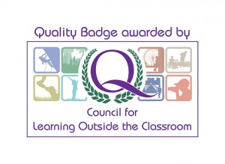
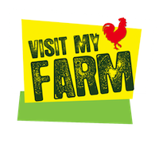
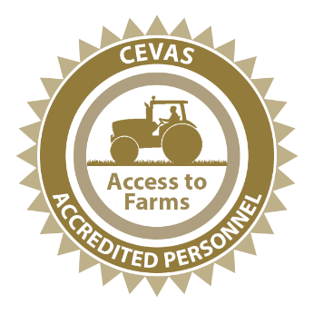
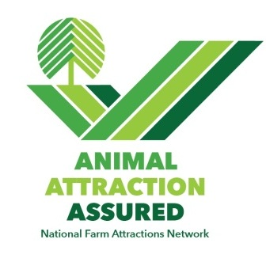
We will reply by email with a programme and risk assessment advice/information.

